Jonathan Kosir

Homework 8

ECE 425

3/29/2018

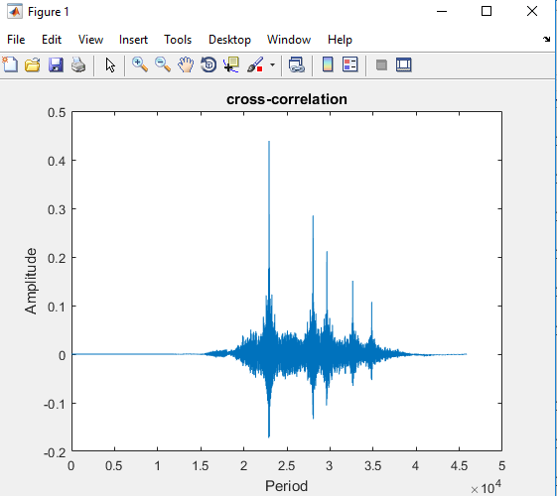

In this program after we recorded our voice, then corrupted it, we did a normalized cross-correlation of our voice. Once we got this results back we used MATLAB to plot it. In this image above you can see 5 long lines that extend upward. Each one can be guessed to be a path. Therefor we can assume that this normalized cross-correlation has approximately 5 paths. With this we can look at the approximate difference between the five of them. By just looking at this graph and making an estimation we can say the approximate average difference in between each path is about a little over .25. After playing the voice everything seems like it came out correctly and the image appears to confirm that.